9


2019





RED ROSE RAMBLINGS
ANNUAL
2019



Email – trredrose@hotmail.com

WELCOME TO THE RED ROSE RAMBLINGS ANNUAL 2019

It has been a busy year at Red Rose and hopefully once the festivities are over you will find some time to look back at what we have been up to in 2019.
2020 kicks off with our AGM at the Cock at Budworth on the 12th January with lots of awards and prizes for those who have made a contribution to the group in 2019, Come along and join us. You never know it could be you going home with an award or prize.
Red Rose events schedule will be available at our meeting on the 16th February and we can promise you a packed year with something for everyone.
Red Rose is changing and growing and there is something for everyone, even if you don’t regularly attend meetings or events, why not take advantage of the opportunities the group offers and come along and join us at one of our meetings – We promise you a warm and friendly welcome

All the best for the New Year and Happy TR Motoring for 2020

Jonathan smith – Red Rose Group Leader

JANUARY
Our first meeting of the year was also the AGM and we had quite a turn out with a full room at the Cock at Budworth! The meeting got underway with Jonathan giving a light hearted summary of the year. I am sure that everyone who was at the meeting would agree that there are a lot of opportunities for everyone at Red Rose with a wide selection of events throughout the year. The meeting quickly moved on to the formality of the voting with no change to the 2018 committee members

RED ROSE 2019 COMMITEE MEMBERS
Group Leader  - Jonathan Smith  Deputy Group Leader  - Tim Davies  Treasurer  - John Leleu  Fund Raising  - Mike and Pauline Grimes  Red Rose Bulletin / TR Action report  - Jonathan / Caroline Smith | Events  - Caroline Smith  - Mike / Carole Biddulph  - Sandra Baran  - Bob Eccles  Shows  - Chris Briggs  New members Secretary  - Tim Davies  Web Site Editor  - Phil Moss  Face Book Administrator  - Caroline Smith

Once the formalities of the AGM were over the meeting moved onto the main event - The 2018 Red Rose awards!

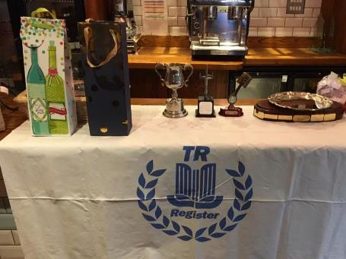

Mike Connery Plate
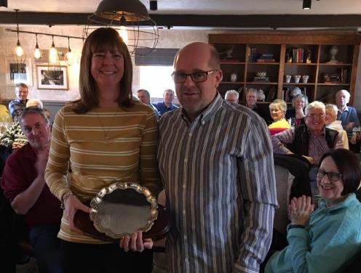
Voting was very tight for the best run of the year with nine runs to choose from. Winners were Jonathan and Caroline Smith for the Drive It Day joint group run to Crich Tram Way museum with Stoke and Trent groups. Second place was again taken by Jonathan and Caroline for the Autumn Leaves run to RAF Cosford with Richard and Sian Chandler picking up third place for the Summer Run to the Cai Dai Museum.
If you have a place you would like to visit in 2020 or would like to organize an event or short run after the monthly meetings email Jonathan /Caroline at trredrose@hotmail.com or join us at the events meeting on Sunday 16th February

Red Rose Cup

The Red Rose Cup was awarded to John and Jane Leleu in recognition of John’s abilities as Club treasurer to restrain Jonathan’s spending over the last few years, production of the marquee plaques which are continuing to be a great success at car shows on our club stand and the much anticipated trip to the Isle of Wight which took place in June.

New Contributors Award
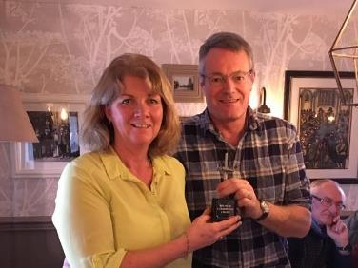
This was a new award for members who have for the first time made a contribution to the club. The award was presented to Richard and Sian Chandler who took on the organization of the summer run; supported TR Fest and Sian also knitted squares for the women’s refuge.

Red Rose Group – Club / Marquee Promotion award

Another new award was The Club Promotion Award .This was presented to two members, David and Tracie Bailey and Hamish and Suzie Roscoe. David races his orange TR4 in the Swinging Sixties Race series and Hamish races in the Remington TR series in his TR3A

Both took home some liquid refreshment to share with their understanding and supporting wives in recognition of their efforts in the race series and for promoting the club and marquee.
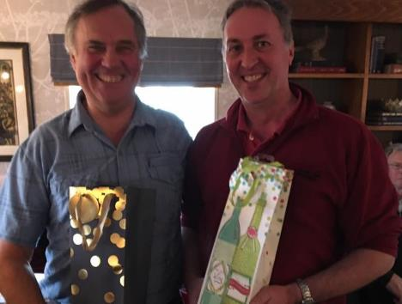

Red Rose Award for support of the group in a particular activity

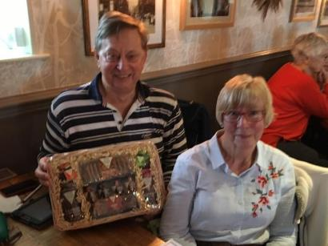
This year a hamper was awarded to Mike and Pauline Grimes who took over the raffle in 2018 from Bill and Anne Redrobe. Anyone who has attended one of our monthly meetings will know what a hard act this was to follow but also how important the raffle is to the club in ensuring we are able to continue offering a wide range of events.

Broken Spanner Award
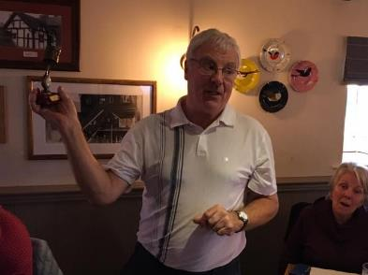
For the first time in a few years there were a number of potential contenders for this award with Group leader Jonathan, Area Director Bob and Ken Harrison almost but not quite making the cut. This year’s clear winner was John Leleu for fulfilling the requirement of failure to proceed.

Red Rose Facebook Group Prize Draw

This year’s Facebook prize draw was won by Tracey Lamb, a worthy winner who regularly contributes to the face book group. Tracy opted for the £20 Marks and Spacer voucher.

If you placed a posting on the Red Rose face book page in 2019 you will be automatically entered into this year’s face book draw which will be drawn at the AGM on the 12th January

The ongoing commitment and help of the following members was also noted and appreciated by the committee team

- Following the renovation of the Antrobus Arms John and Jane Bell for proposing the Cock at Budworth and a suitable new venue

- All those who helped with 2018 TR Fest were thanked.

- Bill and Anne Redrobe for their longstanding commitment to the group, monthly raffle / fundraising which has funded a number of events over the last few years.

- Andrew Haywood for his continuing support organizing the Manchester car show and Car Fest Red Rose / TR Register stand

- Anne and John Thorpe for encouraging the club to support a women’s refuge by knitting squares for blankets Anne presented an example of the blankets produced with the support of the club and thanked all those who had made a contribution. Anne also donated some of our calendars to the refuge

The meeting was closed by Jonathan who once again thanked everyone who has supported the club and attended events over the last year and concluded that with everyone’s continued support the club will continue to grow and offer a wide range of opportunities for all.

FEBRUARY

February saw us gather once again for the events meeting with another full house, in fact we had to draft in more chairs! Jonathan chaired the meeting in his usual style with plenty of humor thrown in!
It was a busy meeting with lots to get through including the results of the questionnaire. After a bit of arm twisting from Jonathan we had volunteers for Sunday runs and events so a big thank you to everyone who contributed in 2019.
If you have a burning desire to organize a run or are willing to lead an existing pre done one then email us at trredrose@hotmail.com or join us at our events meeting on the 16th February. Your help would be greatly appreciated!
MARCH

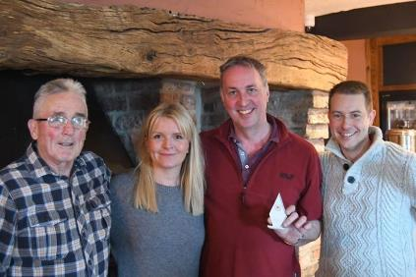
Our March meeting and photo competition was once again a sell out with extra chairs having to be brought in once again! Although due to a power failure it very nearly didn’t happen. Fortunately power was restored in time and the only casualties were the Yorkshire puddings that had sunk in the oven!
A big thank you to everyone who sent in their photos and apologies to those who’s photo’s seemed to have got lost somewhere in cyber space! We are now taking entries for the 2020 competition – 2 photos per couple

The 2019 winners were Hamish and Suzie Roscoe, Phil Moss was 2nd and Martin and Lynne Hill were 3rd.The top 12 2019 photos will feature each month on the Red Rose Face Book cover page during 2020. Email your photos to Jonathan and Caroline at trredrose@hotmail.com

2019 RED ROSE PHOTOGRAPH COMPETITION TOP THREE

1st place ‘On the rocks’ Hamish & Suzie Roscoe
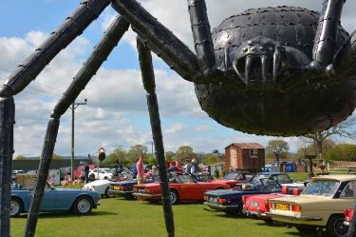
2nd place ‘Tarantula’ Phil Moss
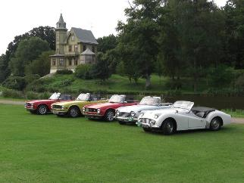
3rd Place ‘Sweden 2008’ Martin & Lynne Hill
NEC – CLASSIC RESTORATION SHOW

Despite the inclement weather there was a good turnout at the NEC for the Practical Classics Restoration Show on the 22nd, 23rd and 24th March with the TR Register Stand looking, as always, very impressive with a great display of cars

APRIL

Here at Red Rose our monthly meetings continued to go from strength to strength and our April meeting was no exception with the landlady struggling to find chairs and space at another full meeting. This chair thing is getting to be a running theme!
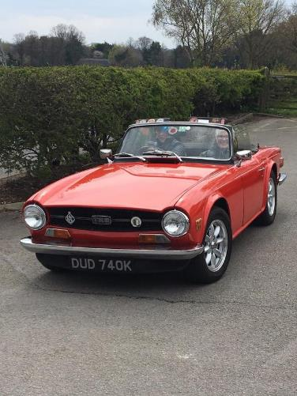
Jonathan shared all the news from the group leaders meeting with lots of positive feedback not to mention the efforts being made by the management team in particular the efforts of the new Forum team. If you haven’t recently visited the forum please give it a try as it provides a vast resource of information including a few sections for those less technically minded.

The post meeting run to Manley Mere, our first of the year, was a great success with over fifteen cars braving the chilly spring weather to enjoy afternoon tea in the recently refurbished café. Another well organized run by John and Anne Thorpe!

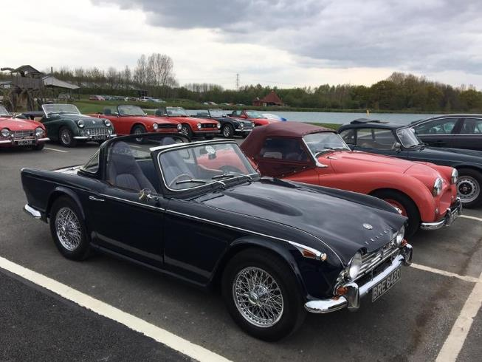

GROUP LEADERS MEETING 7TH APRIL

Jonathan and Caroline attended the annual group leaders meeting at Gaydon motor museum which was the perfect venue for a car club and the meeting itself was very interesting with much to talk about.

The group leaders meeting provided the opportunity to meet up with other register members and hear their views on a variety of subjects. There were lots of healthy discussions and debates and we are pleased to report that the management team are listening to our views and making some progress on the actions identified at the 2018 group leaders meeting!

If there is anything you would like raising at this year’s group leaders meeting in March email us at trredrose@hotmail.com

Drive it day 28TH APRIL

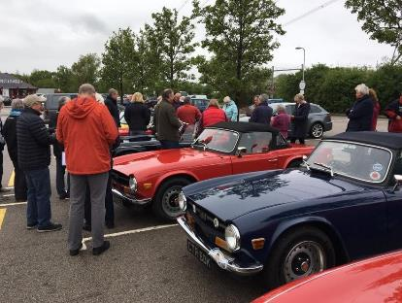
This year’s drive it day was to the RNLI Lifeboat Station at Hoylake with nineteen cars attending.

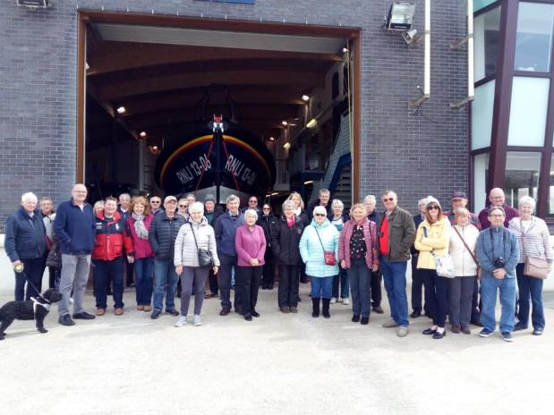
After visiting Port Sunlight, Church Farm, and Leasowe Castle for Sunday lunch we stopped off at the lifeboat station with the privilege of having our cars lined up on the slip way in front of the station. The RNLI volunteers treated us to a guided tour of the station which was very informative and everyone was amazed and impressed by the service provide by the RNLI which is solely funded by donations. Red Rose collected over a hundred pounds in thanks.

The event would not have been the success it was without the sterling efforts of Tim and Karen Davies who organized the event from start to finish. Many thanks to Tim and Karen for a job well done

May

We didn’t manage to attend the May meeting as we were acting as ambassadors for Red Rose and taking a trip to the dark side and joining the Cheshire MG Owners Club on their annual Candles Charity Run. The run is open to all marquees and our newly acquired Geranium long door TR2 certainly stood out as one of the very few TR‘s surrounded by the usual contingent of MG’s. We would highly recommend this event to anyone who enjoys spending an afternoon wandering around the Cheshire countryside, with all the proceeds going to charity

Whilst we were gallivanting around North Wales in our TR2 our area director Bob Eccles took up the reigns to chair the meeting and David and Tracie Bailey organized the post meeting run to Grapenhall Walled Gardens.
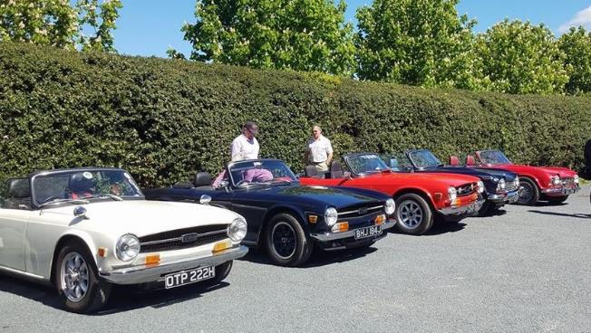


Over the May bank holiday weekend we had six cars on The Weaver Wander navigational run ,a group of Red Roser’s headed off into mid Wales for the substitute Traws weekend and Mike and Carole Biddulph enjoyed a weekend away at the Donington Historic Festival. Later in the month a band of Red Roser’s travelled down to the National TR6 Day at Wroxall Abbey with over 100 TR6 ‘s and 200 more Triumph models attending.
Bringing May to an end three cars took part in the Prestatyn Classic car run enjoying a scenic run through North Wales
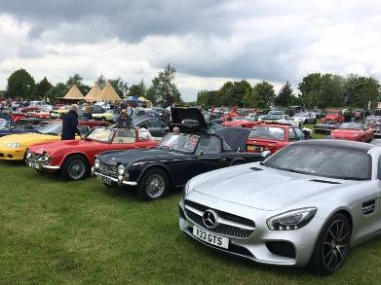
Fuzz Townsend waving off Red Roser’s at Weaver Wonder
Weaver Wonder

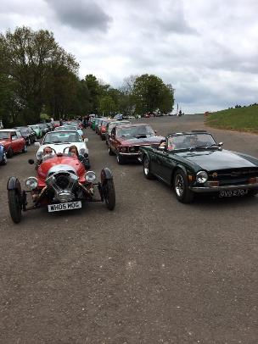
Donington Historic Festival

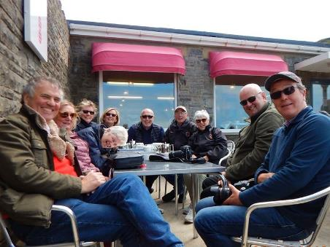
THE NOT TRAWS GANG ENJOYING AFTERNOON TEA

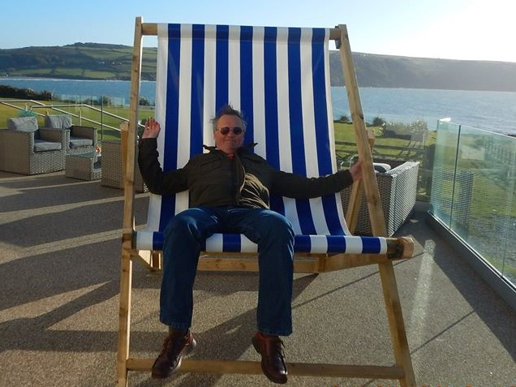
BIG CHAIR OR MINI DAVE?

June - What a busy month June was!.

1^{st and} 2nd June
The first day of June dawned bright and sunny for the Tatton car show but I believe hoods were up on the Sunday. Red Rose did us proud winning three Prizes! Jonathan got car of the day, Peter Marshland won best convertible and the Red Rose stand came third! Well done to all our winners!

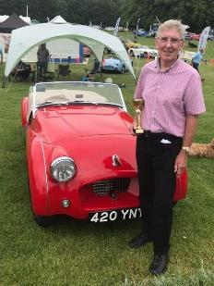
Jonathan - Car of the day
Peter Marshland winner best convertible

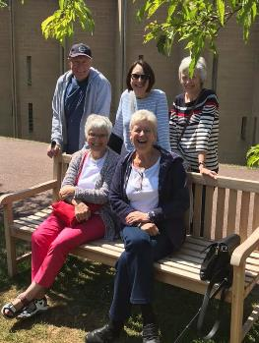
2nd – 8th June - Isle of Wight
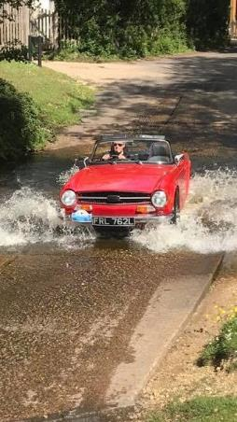
On the 2nd of June nine cars took the roads for a trip to The Isle of Wight visiting Beaulieu on the way. Once we had negotiated boarding the ferry and arrived on the island we visited Osborne house and Ventnor Botanical Gardens. We were also very lucky to be given a guided driving tour by the only TR Register member on the island Paul “Pinky” White, Thank you to Pinky and his lovely wife for taking the time to show us things we wouldn’t normally have seen.
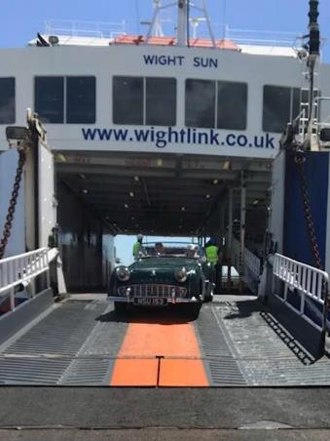
Back on the mainland we drove through the New Forest and visited Bucklers Hard where we took a boat trip in the sunshine! Then it was on to The British motor museum on our last day.
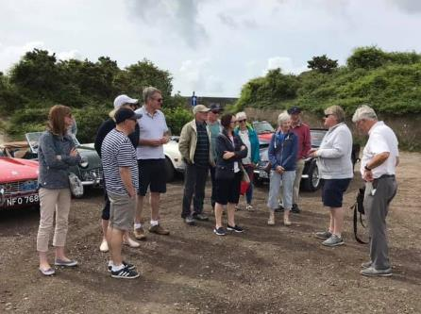
The holiday was a huge success and everyone had a great time thanks to the sterling efforts of John and Jane Leleu who organized the whole trip. Thanks to both of them for all their hard work. Everyone is already looking forward to the next Leleu organized trip! Scotland this time!

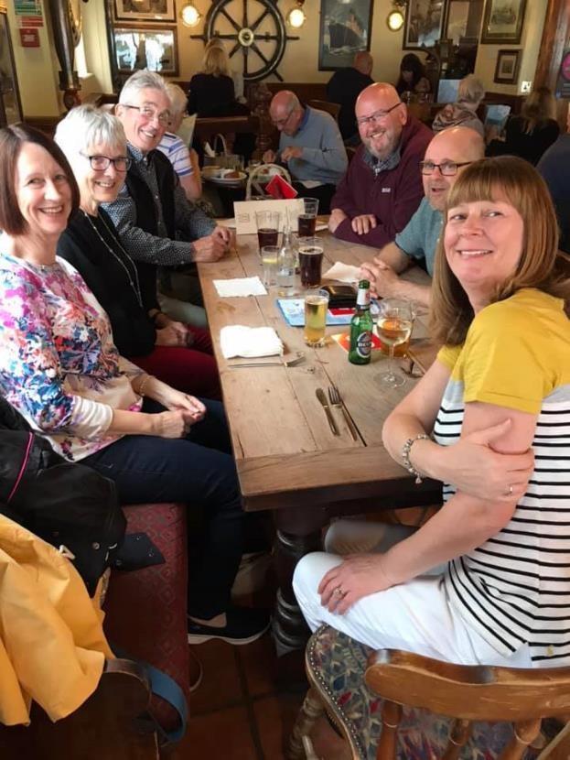
Isle of Wight Crew Evening meal

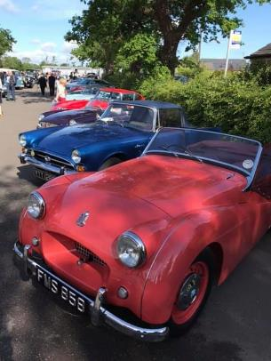
9th June Big Boys Breakfast and Lyon Salt Works Vintage Festival

The 9th June meeting was more a day of events, We started off the morning at The Antrobus Village Hall for The Big Boys Breakfast and car run where I think the whole village turned out to enjoy a cooked breakfast and a look at the cars!
Next on the itinerary for the day was our usual monthly meeting followed by a run down to the steam fair at The Lion Salt Works kindly co-ordinated by Keith Nutall

BIG BOYS BREAKFAST

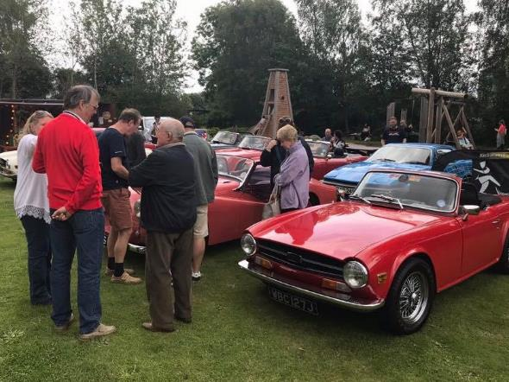
LYON SALT WORKS

16th June
Five Red Rose cars took part in this year’s Peaks and Dales run organized by the Hare and Hounds Classic Car Club covering around 80 miles and ending with a display at the Pavilion Gardens in Buxton.
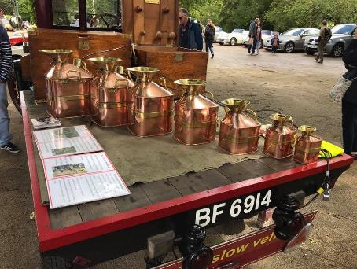

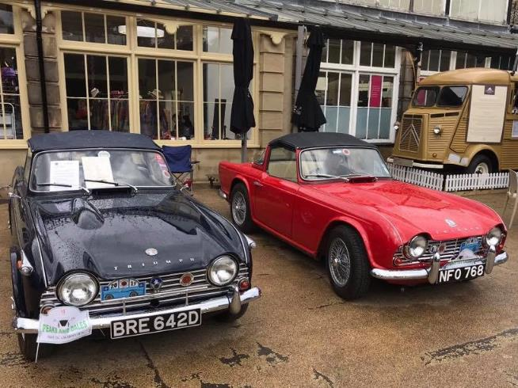

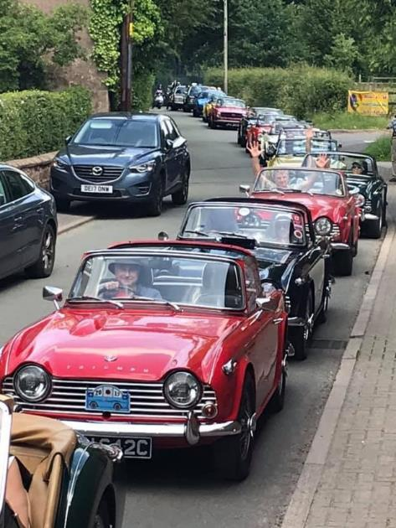
23rd June - Budworth Village festival

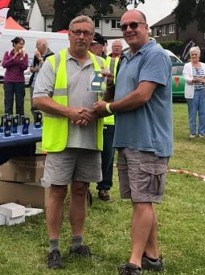
Fifteen cars attended the Budworth Village festival on the 23rd of June, although one car didn’t quite manage to make the event and is now looking like a contender for the broken spanner award! This was a new event for Red Rose and by all accounts proved to be a great day. Once again thanks to Keith Nutall for organizing the event

24th June - Lymm Transport festival

Red Rose cars were at Lymm Transport festival on the 23rd June, an event which goes from strength to strength, with Michael Biddulph picking up the prize for best Triumph in his TR4A.

30TH – 31ST June - Moffat Car Rally
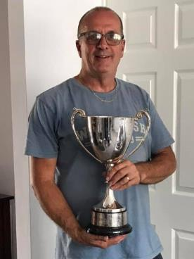
Red Rose cars ventured north of the border for the last weekend of June attending the Moffat Car Rally. A fabulous event with over 300 classic cars enjoying the Scottish countryside on the Saturday run followed by a static show on the Sunday.
Big thank you to Steve and everyone at the Clyde Valley group who made us very welcome and let us share their gazebo to shelter from the rain on the Sunday
One of their members attended the Aysgarth weekend and despite a full boot of camping equipment he managed to find room for an award! Mike and Carole Biddulph had won best non roots car. This is one of the biggest cups I have ever seen and guess who had to bring it home for them!

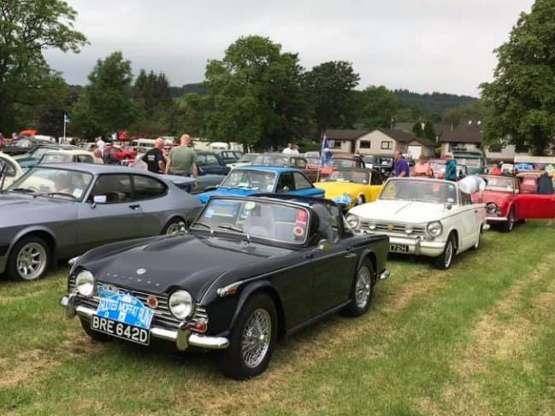
July

The summer so far had been a bit of a wash out but here at Red Rose we were undeterred and continued enjoying our cars.

There was a good turnout for the Aysgarth weekend with six Red Rose cars attending and enjoying what was one of the nicest weekends of the year. We would highly recommend this event and the runs were some of the best we have ever done! Many thanks to Ian Landen and his team for organizing such a great weekend. We will be back for 2020! 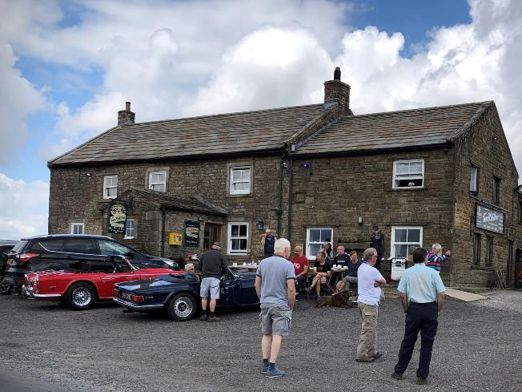
AYSGATH WEEKEND – STOP OFF AT THE HIGHEST PUB IN BRITAIN

Car Fest North was not without its problems! I think it was renamed Mud Fest! However despite all this those that attended had a good time and helped each other off site when the cars got stuck in the mud! Huge thanks to Andrew Hayward for organizing the cars once again and to everyone who displayed their cars and showed what strong stuff us Red Roser’s are made of!
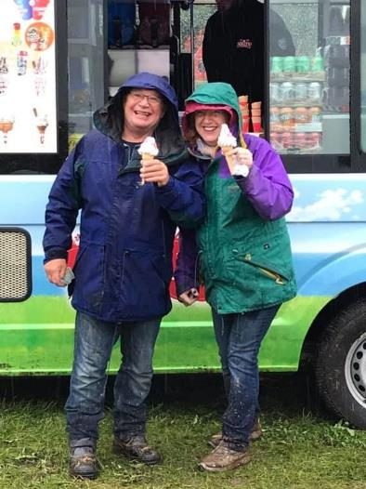
Meanwhile at the other end of the country the hunt was on to find the TR Register stand at The Silverstone Classic! It was eventually located in a car park! Silverstone is a fantastic event and if you combine it with The Retro Run you get a great deal on your entry ticket!

The month ended with a group of Red Rosers enjoying a day on the Danny cruising the river Weaver. A great day was had by all and many thanks to John and Ann Thorpe who kindly organized the event

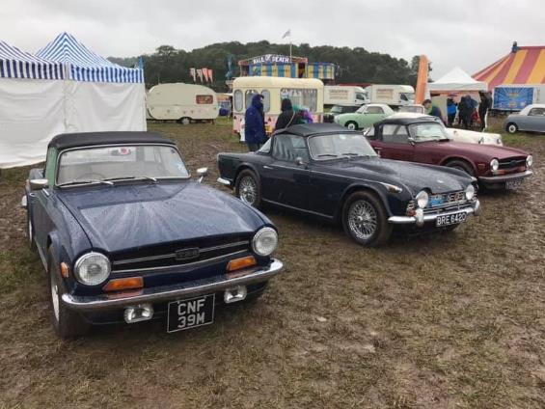

AUGUST
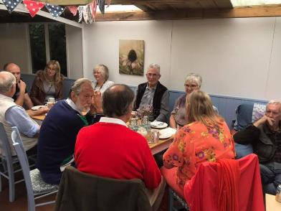
The August meeting was relatively quiet due to many of our members being on holiday but Sian and Richard Chandler very kindly organized a run to the Bluebell Nursery which was enjoyed by all who attended


The International this year was in Stratford which was a new venue. We have had mixed reviews on its success but Red Rose were out in force and despite the wet conditions we still came away with some of the top awards from the Register. Mike and Carole Biddulph won the Pride of Ownership with their TR4 and also scooped best interior, Jonathan Smith won best non standard TR2 and Pete Napper was awarded best standard TR2.Well done to them all! Especially Pete, who broke down on route, arrived on a tow truck, fixed the problem and still had his car ready for the judging!

2020 IWE will be returning to Stratford to celebrate the 50th anniversary of the TR Register. We have been assured by the management team that many of the issues experienced in 2019 will be addressed so why not come along and join us to celebrate a milestone for the Register and everything TR. We would advise booking accommodation early though to avoid disappointment

August bank holiday weekend was The Gold Cup at Oulton Park where we teamed up with some other groups from the Register and managed a very impressive display of TR’s with 56 turning up on the Monday! This was even more of an achievement when you take into account the failure to proceed from a certain Bob Eccles who had all the tickets! The award for the broken spanner is going to be a tough choice this year!

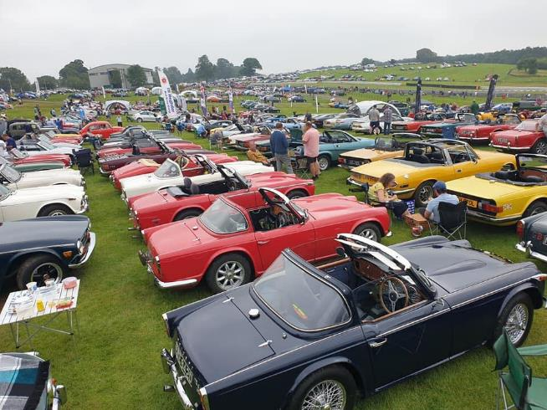

2020 will be the Registers 50th anniversary and to celebrate this each regional group has been asked to host an event. The North West region will be holding an event over the August Bank holiday weekend which will include the Oulton Park Gold Cup on the Bank holiday Monday and a run on the Sunday. Arrangements are already well in hand with options for accommodation, formal dinner on the Sunday and free entry to Oulton Park Gold Cup on the Saturday , Sunday and Monday for the car and driver. The TR Register stand will be made available and TR2 will also be in attendance for the weekend. If you are interested in attending the event or have any suggestions for the weekend email Jonathan and Caroline at trredrose@hotmail.com

The end of the month saw a first for us. We attended the Bo’ness revival in our geranium long door TR2 along with a few other Red Rosers’ and their cars.
The event this year celebrated the opening of the new Jim Clark museum with a run to Duns on the Saturday where the museum is located followed by a static display on the Sunday with the TSS club which included a timeline of triumph cars. We won best TR and best Triumph in the show and Keith and Linda Lewin won best non side screen car in their black TR4A - This is a great event and well worth the long journey!

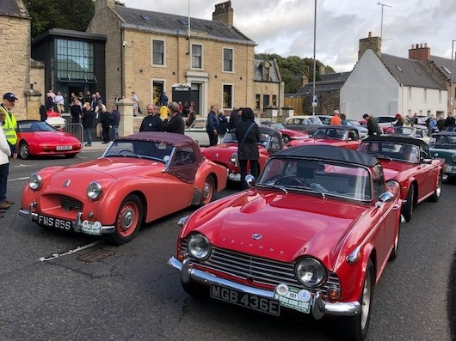
SEPTEMBER
For our September meeting we once again teamed up with some other local groups for a run to TR Bitz. Craig opened up the workshop and along with Johnny and the rest of his team treated us all to a very impressive spread of food and drinks especially the scones! They offered free valuations and were on hand to answer questions on all things TR related. On behalf of all who attended we would like to thank everyone at TR Bitz for an amazing afternoon which you will be pleased to know Craig hopes to repeat again in 2020.

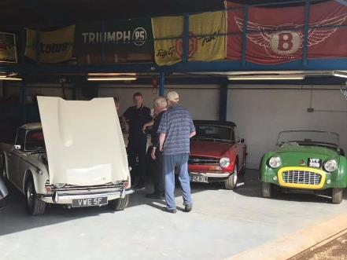
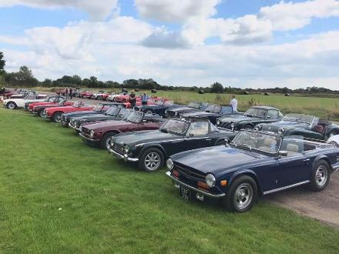
OCTOBER
Sadly there was no Autumn Leaves run in 2019 which has historically been a well attended event- Hopefully there will be some more support in the new year with a volunteer to organize the run so we can all enjoy our cars before the close of the season.

Our October meeting was well attended by lots of our regular members and some of our newer ones made a return visit! Nice to see we didn’t scare them off!

Jonathan Smith updated us on various TR happenings, with much discussion regarding the venue for the 2020 International Weekend which we now know will once again be in Stratford

Bob Eccles our regional director informed every one of the plans for a regional event over the August bank holiday weekend to celebrate the TR Register’s 50th Anniversary in 2020 (as previously mentioned this will now tie in with Gold Cup)

We have already started to plan the events calendar for next year so if there is an event you would like included or you have a burning desire to organize an event or a post meeting run then please email us at trredrose@hotmail.co.uk.

As our deputy leader Tim had moved to pastures new we announced that we now had vacancies for a deputy group leader and a new member’s secretary

We have now filled these posts and shall be announcing who the brave volunteers are at the AGM!

November
Once again the Classic Car Show at the NEC proved to be a very popular event. The stand was looking good with a TR6 theme to celebrate the 50th anniversary of the launch of the TR6. 1955 Le Mans TR2 PKV 374 was the star lot at the Silverstone auction selling for a reported £258,750.
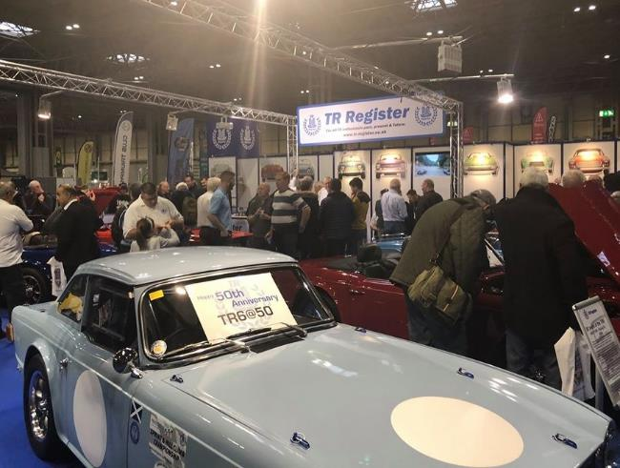
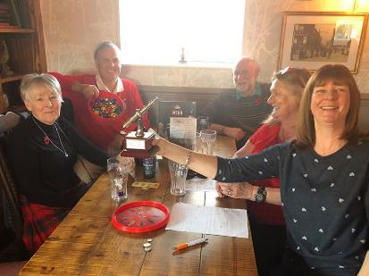
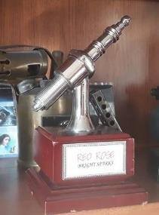
The November Red Rose meeting could only mean one thing the annual Quiz! Thank you to David Rhodes for once again taking on the role of quiz master. The questions this year were as usual an eclectic mix with the winning team getting a very impressive score!

December
The final event for us in 2019 was our Christmas lunch with over 50 Red Rose members enjoying the festive fun in their Christmas jumpers at the Cock at Budworth. We had a bumper raffle and a Christmas themed table quiz.
There was much talk of the year ahead with updates on the International weekend in Stratford and our plans for the 50th birthday celebrations planned to coincide with the Gold Cup at Oulton Park over the August bank holiday weekend.

2019 has seen Red Rose continue to grow as group and we are looking forward to welcoming you all back in 2020

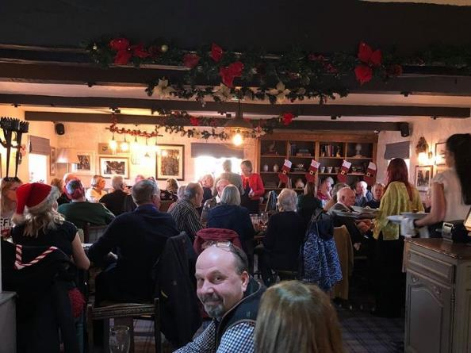

RED ROSE MEETING DATES 2020
January 12th AGM,
February 16th Events
March 15th Photo competition,
April 19th
May 10th
June 14th
July 12th
August 9th
September 13th
October 11th
November 8th Quiz
December 13th Charismas Lunch
Venue
Cock at Budworth, Great Budworth,
Warrington Rd, Northwich CW9 6HB
From mid day

2019 RED ROSE PHOTOGRAPH COMPETITION TOP TWELVE
1st place ‘On the rocks’ Hamish & Suzie Roscoe
2nd place ‘Tarantula’ Phil Moss
3rd Place ‘Sweden 2008’ Martin & Lynne Hill
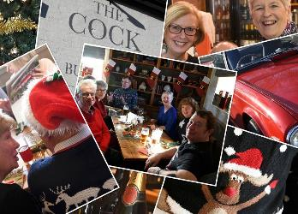
4th – ‘Christmas collage’ John & Jane Leleu
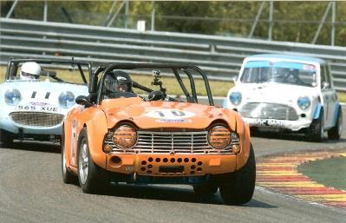
5th Photo 22 – David & Tracie Bailey
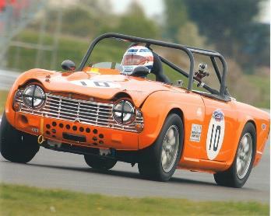
6th Photo 19 – David & Tracie Bailey
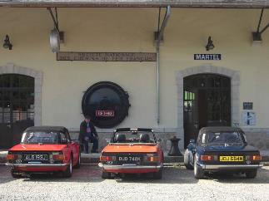
7th Photo 8 – Martin & Lynne Hill
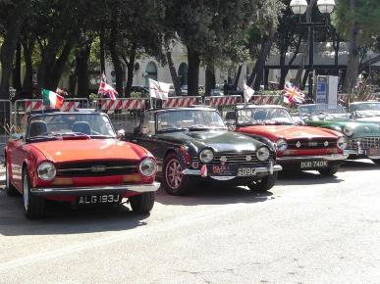
8th Photo 9 – Martin & Lynne Hill
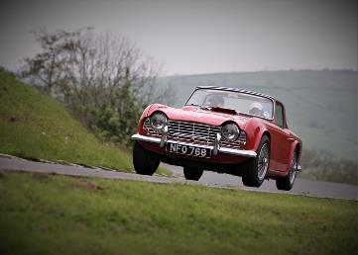
9th Photo 44 – Jonathan & Caroline Smith
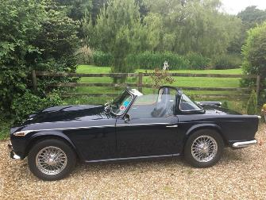
10th Photo 12 – Mike & Carole Biddulph
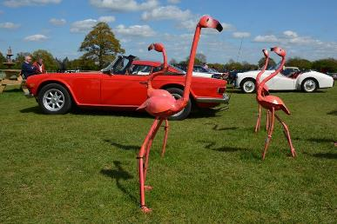
11th Photo 62 – Phil Moss
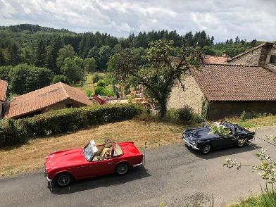
12th photo 42 – Jonathan & Caroline
RED ROSE FACEBOOK POST 2019

Caroline and Jonathan Smith
Mike and Pauline Grimes
Michael and Carole Biddulph
Mark Lamb
Barry Lucas
Tim Davies
John Winterbottom
Ian and Sue Wilde
Matt Houghton
Dave Mullan
Harold Hughes
Rosemary and Nigel Moss
Shawn Frank
Ian Lewis
Sian and Richard Chandler
Tracie and David Bailey
Ronnie and Steve Dyne
Antony Davies
Gordon and Hazel Bayley
John Leleu
Trevor Moores
Anne Redrobe
Tony Wilson
Andrew Heywood
Tony Sherin
Linda Stringer
Peter Fenlon
Doreen Smith
Shawn Frank

AND FINALY - OUR FAVOURITE FACEBOOK POSTS OF THE YEAR
TONY WILSON 21ST SEPTEMBER
Satnav – A new poem
I have a little Satnav; it sits there in my car. A Satnav is a driver's friend it tells you where you are. I have a little Satnav; I’ve had it all my life. It's better than the normal ones, my Satnav is my wife.
It gives me full instructions, especially how to drive "its sixty miles an hour", it says, "You're doing sixty five". It tells me when to stop and start, and when to use the brake and tells me that it's never ever, safe to overtake.
It tells me when a light is red, and when it goes to green It seems to know instinctively, just when to intervene. It lists the vehicles just in front, and all those to the rear. And taking this into account, it specifies my gear.
I'm sure no other driver, has so helpful a device. For when we leave and lock the car, it still gives its advice. It fills me up with counselling, each journey's pretty fraught. So why don't I exchange it, and get a quieter sort?
Ah well, you see, it cleans the house, makes sure I'm properly fed. It washes all my shirts and things, and keeps me warm in bed!
Despite all these advantages, and my tendency to scoff, I only wish that now and then, I could turn the bugger off.
MIKE GRIMES 28TH FEBRUARY – CANINE TOOLBOX
