
TR Register Shropshire Group’s
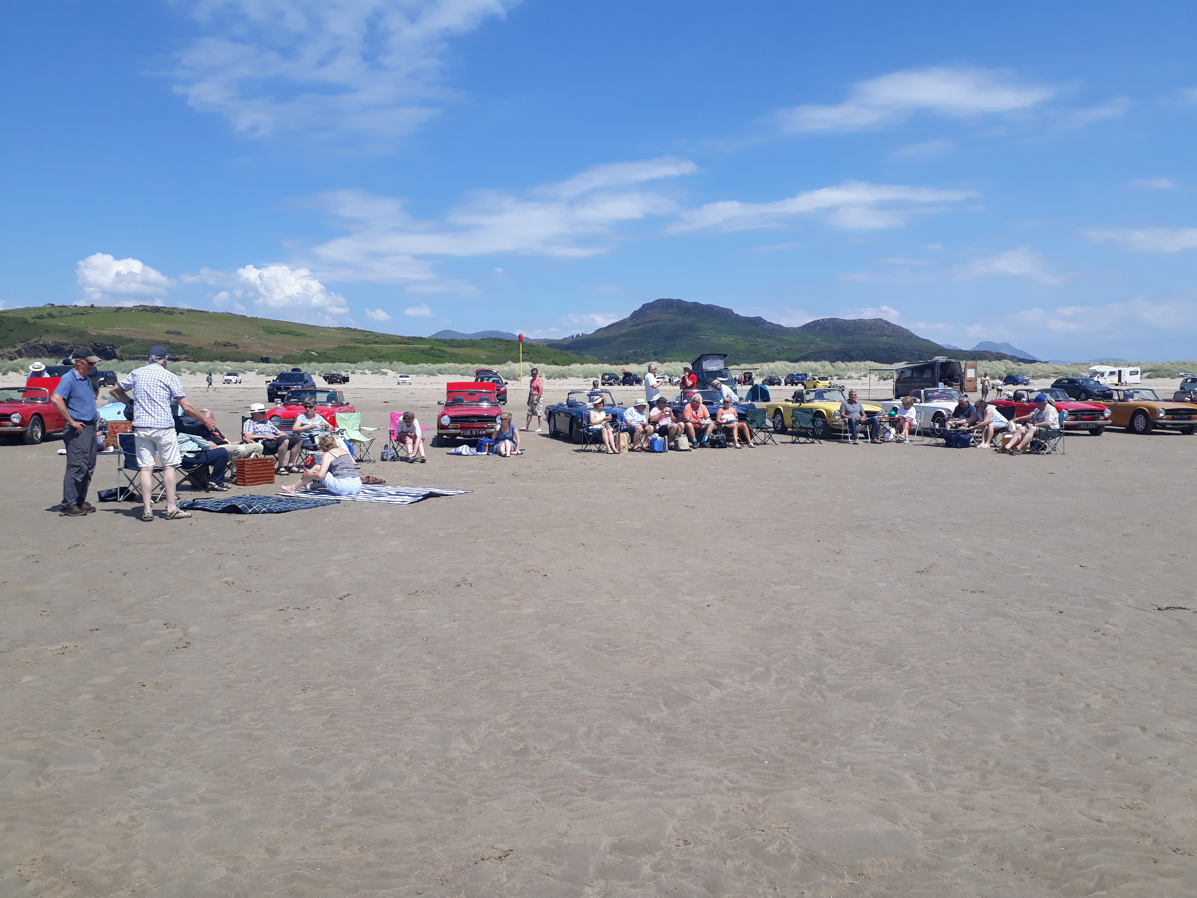
Picnic at Black Rock Sands
29th June 2023

Itinerary: (times are approximate)
10:00 | Depart Salop Leisure
11:20 | Arrive National White Water Rafting Centre, Bala for morning break
12:00 | Depart White Water Rafting Centre
13:00 | Arrive Black Rock Sands
14:30 | Depart Black Rock Sands
16:10 | Arrive Llanfair Caereinion
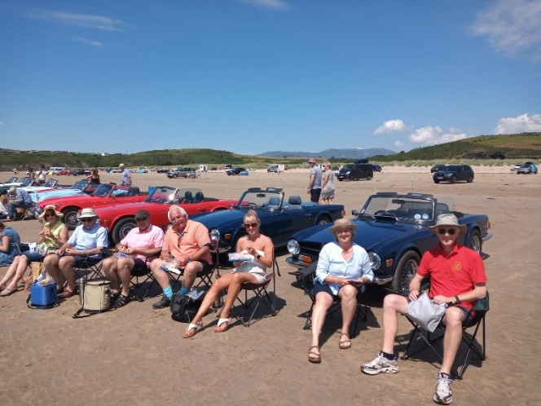
Repeating last year’s scenic run over the Berwyns to Black Rock Sands and parking on the beach for a picnic (bring your own, there are no shops or cafes at the beach but there are toilets). The return is via Dolgellau and the Bwlch yr Oerddrw pass (Crimea Pass) on the A470 to the station Café at Llanfair Caereinion for a tea stop.
Contrary to its name, Black Rock Sands is a wide expanse of fine golden sand backed by grassy sand dunes between Porthmadog and Criccieth. It is also known for visits by T. E Lawrence of Lawrence of Arabia fame (he lived nearby) and from the poet Shelley.
The sand is hard enough to drive on and cars are allowed on beach for a daily charge of £5.
Suggested Drive Overview
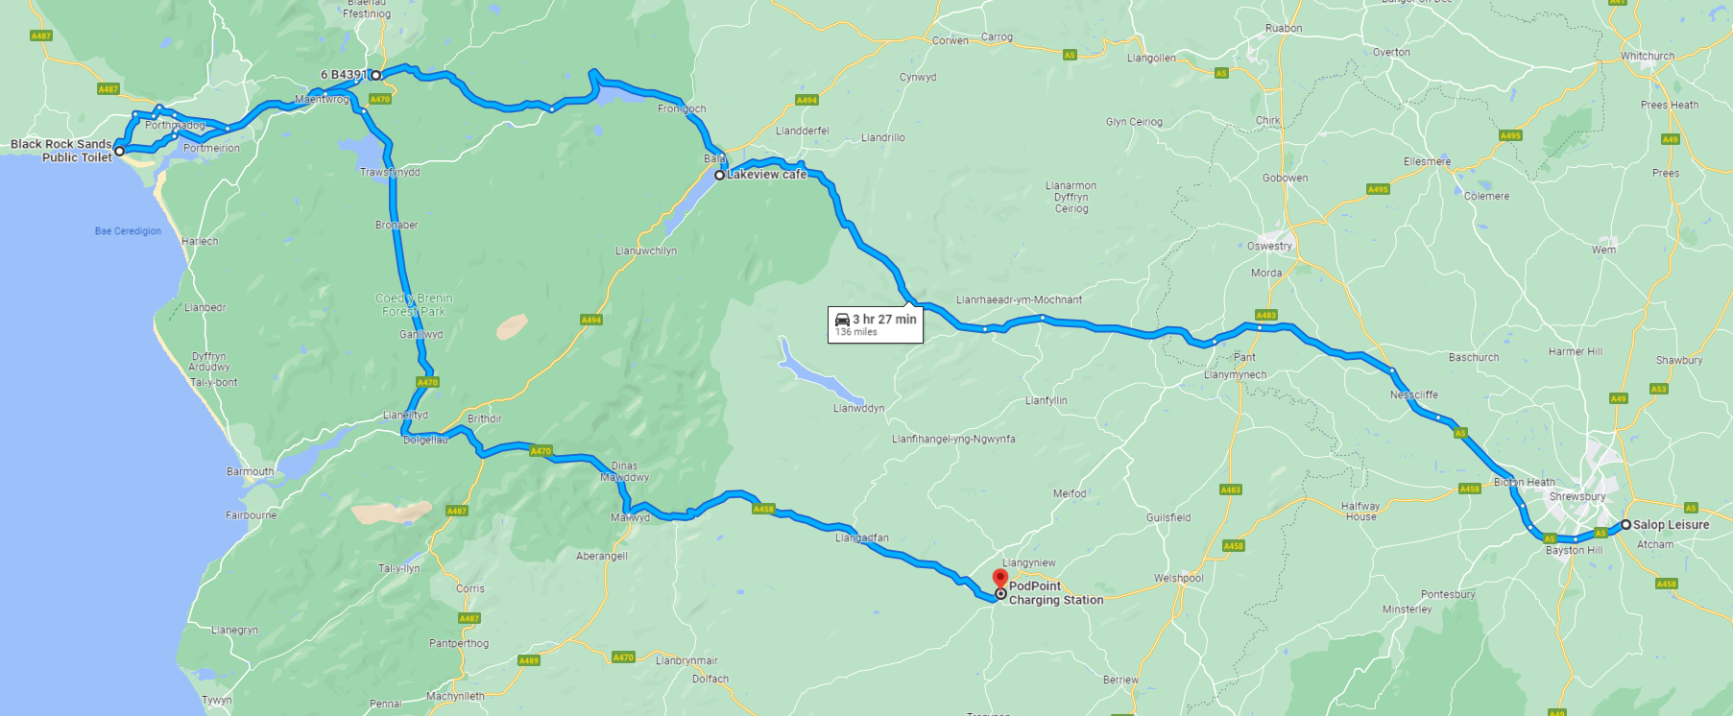
https://goo.gl/maps/jqHwDeviHY6GQyNP6

