
TR Register Shropshire Group
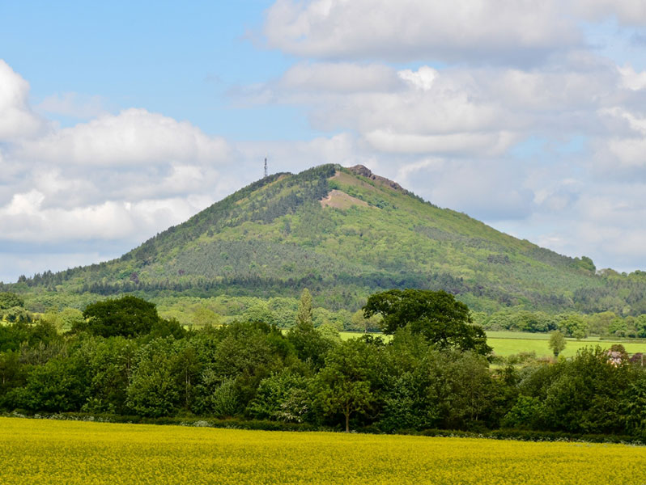
Goes All Around The Wrekin
Saturday 7th June 2025

The Wrekin rises sharply out of the Shropshire Plain to a height of 1335 feet and is comprised of volcanic rock. There is an Iron Age hill fort on the summit. It is believed that the fort was built by the Cornovii tribe and was once their capital. For several centuries the hill was known as Mount Gilbert, a name given to it by the Normans after a hermit who lived there. From the summit, travelling due East, the next highest point is in the Ural Mountains.

According to local legend, a Welsh giant, called Gwendol Wrekin ap Shenkin ap Mynyddmawr, who had a grudge against Shrewsbury plotted to flood the town by dumping a spadeful of dirt into the River Severn thus destroying the town and drowning its inhabitants.

En route to Shrewsbury, the giant came across a cobbler whilst having a rest near Wellington. The cobbler, who had walked from Shrewsbury with a sack full of shoes to repair, told the giant that Shrewsbury was a long long long way away. He showed the giant his sack of worn shoes, saying he had himself worn them all out on his journey from Shrewsbury. This immediately put the giant off his plan. He dumped his spade of dirt by the side of the road and then headed home.

The spade of dirt then became The Wrekin, whilst the smaller mound of dirt created by cleaning his boots, became the Ercall, a smaller hill next to The Wrekin.

Readily understood in the West Midlands - and utterly baffling to most living outside the region - "going all around the Wrekin" is generally used to describe someone, or something, that is taking much longer than necessary to arrive. So that’s just what we will do – we will spend a lot of time going nowhere without ever losing (theoretical) sight of the Wrekin.
Itinerary:
10:00 | Meet at Salop Leisure, Emstrey, Shrewsbury, SY5 6QS, for a morning coffee. This on the B5380 from the A5 Shrewsbury bypass towards Atcham
10:30 | PROMPT Start of run.
11:30 | Arrive at RAF Museum, Cosford, TF11 8UP (or use WV7 3EU). Car parking £4 – museum entry free
12:45 | Depart Cosford
14:15 | Arrive at The Kynnersley Arms, Leighton, SY5 6RN
14:30 | Late Sunday Lunch
Contact: Roger Critchley trshrops@gmail.com 01743 790253/07811 260166

